Ghoti’s slide puzzle

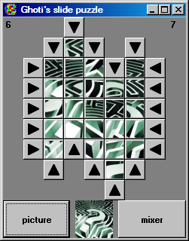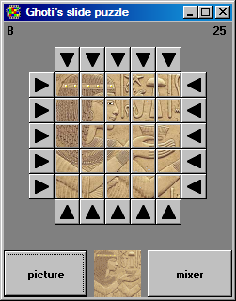
Click the buttons to move the tiles.

The nasty complication is that the leftmost, rightmost, top and bottom rows can be blocked by the buttons used to move tiles as these buttons will only move either horizontally or vertically. In the picture above left both the top and bottom row are blocked this way.

The game target is to slide the tiles about so that they end up matching the sample picture, as shown in the picture top right.

With the left button the image can be changed, the right button resets the puzzle and then uses 50 moves to mix it up. The number of moves used by the player is shown top left, the number of tiles placed correctly is shown top right.

Design and production Ad C. Lockhorst
alockhorst@UPCmail.nl

Images used web sourced …..

